|  |  |
| --- | --- |
| [USED-1] [Application accepts random email ID during User Sign - Up](https://saraswathy.atlassian.net/browse/USED-1) Created: 09/Apr/19  Updated: 09/Apr/19 | |
| **Status:** | To Do |
| **Project:** | [Used](https://saraswathy.atlassian.net/secure/BrowseProject.jspa?id=10000) |
| **Component/s:** | None |
| **Affects Version/s:** | None |
| **Fix Version/s:** | None |

|  |  |  |  |
| --- | --- | --- | --- |
| **Type:** | Bug | **Priority:** | High |
| **Reporter:** | [Saraswathy Manickam Rameswara Babu](https://saraswathy.atlassian.net/secure/ViewProfile.jspa?accountId=5cab7523a8d493261b3bf5d9) | **Assignee:** | Unassigned |
| **Resolution:** | Unresolved | **Votes:** | 0 |
| **Labels:** | Sign -Up page | | |
| **Remaining Estimate:** | Not Specified | | |
| **Time Spent:** | Not Specified | | |
| **Original Estimate:** | Not Specified | | |

|  |  |
| --- | --- |
| **Attachments:** | defect 1a.jpg     defect 1b.jpg |
| **Sprint:** |  |

|  |  |
| --- | --- |
| **Description** |  |

|  |
| --- |
| Summary : No Email Authentication is done and application accepts random mail ID for sign - up.  Software Version of the device : iOS 12.2  Page : Sign - up page  Steps to reproduce: 1. User clicks the sign-up button 2. User enter the invalid email ID and password. 3. User confirms the email and password. 4. Clicks on the sign - up button.  Expected Results : User should be thrown error message Actual Results : Sign - up successful  Priority : High |

|  |  |
| --- | --- |
| [USED-4] [Feed back is sent successfully even when invalid email format is given](https://saraswathy.atlassian.net/browse/USED-4) Created: 09/Apr/19  Updated: 09/Apr/19 | |
| **Status:** | To Do |
| **Project:** | [Used](https://saraswathy.atlassian.net/secure/BrowseProject.jspa?id=10000) |
| **Component/s:** | None |
| **Affects Version/s:** | None |
| **Fix Version/s:** | None |

|  |  |  |  |
| --- | --- | --- | --- |
| **Type:** | Bug | **Priority:** | Medium |
| **Reporter:** | [Saraswathy Manickam Rameswara Babu](https://saraswathy.atlassian.net/secure/ViewProfile.jspa?accountId=5cab7523a8d493261b3bf5d9) | **Assignee:** | Unassigned |
| **Resolution:** | Unresolved | **Votes:** | 0 |
| **Labels:** | None | | |
| **Remaining Estimate:** | Not Specified | | |
| **Time Spent:** | Not Specified | | |
| **Original Estimate:** | Not Specified | | |

|  |  |
| --- | --- |
| **Attachments:** | 3a.jpg     3b.jpg |
| **Sprint:** |  |

|  |  |
| --- | --- |
| **Description** |  |

|  |
| --- |
| Summary : Feed back is sent successfully even when invalid email format is given and user receives success message.  Software version : iOS 12.2  Label : Product Description  Steps to reproduce:  1.User clicks the Skip button in top left corner of the app, 2. User scrolls down the page to see all the items. 3.User selects the category icon. 4. User clicks the product to be viewed. 5. User sends feed back by clicking on the icon present in the top right corner of the app. 6. User enters the invalid email format.  Expected Result: User should get an error message "invalid email format" when invalid mail ID is given Actual Result: Feedback is sent successfully and user receives the message.  Priority : Medium |

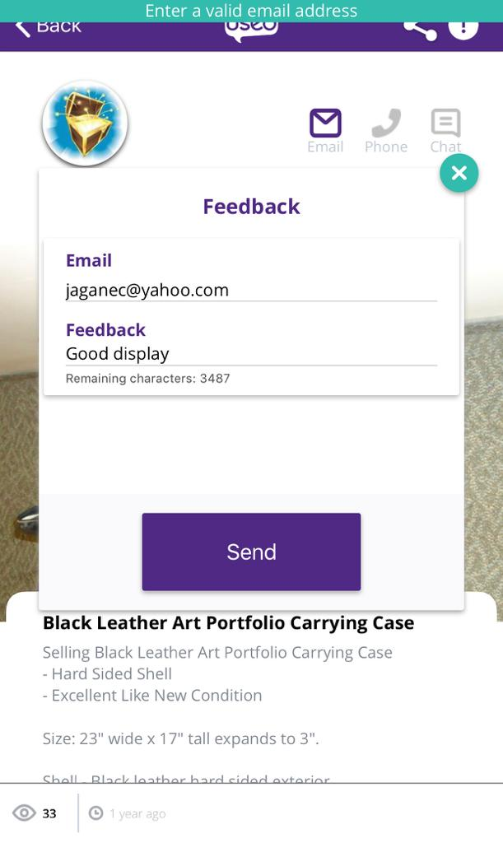

|  |  |
| --- | --- |
| [USED-2] [User is not able to sign up by using system generated password](https://saraswathy.atlassian.net/browse/USED-2) Created: 09/Apr/19  Updated: 09/Apr/19 | |
| **Status:** | To Do |
| **Project:** | [Used](https://saraswathy.atlassian.net/secure/BrowseProject.jspa?id=10000) |
| **Component/s:** | None |
| **Affects Version/s:** | None |
| **Fix Version/s:** | None |

|  |  |  |  |
| --- | --- | --- | --- |
| **Type:** | Bug | **Priority:** | Medium |
| **Reporter:** | [Saraswathy Manickam Rameswara Babu](https://saraswathy.atlassian.net/secure/ViewProfile.jspa?accountId=5cab7523a8d493261b3bf5d9) | **Assignee:** | Unassigned |
| **Resolution:** | Unresolved | **Votes:** | 0 |
| **Labels:** | None | | |
| **Remaining Estimate:** | Not Specified | | |
| **Time Spent:** | Not Specified | | |
| **Original Estimate:** | Not Specified | | |

|  |  |
| --- | --- |
| **Attachments:** | 2a.jpg |
| **Sprint:** |  |

|  |  |
| --- | --- |
| **Description** |  |

|  |
| --- |
| Summary : Sign - Up button is not enabled when system generated strong password is used.  Software version of the device : iOS 12.2  Label : Sign - up page  Steps to reproduce: 1. User clicks the sign-up button 2. User enter the Valid email ID. 3. User tries to enter password 4. User selects one of the suggestions given by the system. 5. User clicks sign -up button  Expected Results : User should sign - up successfully Actual Results : Sign-up is not enabled  Priority : Medium |

|  |  |
| --- | --- |
| [USED-5] [User (guest user) is able to send the feed back when valid email id and feedback is given - Inappropriate error message](https://saraswathy.atlassian.net/browse/USED-5) Created: 09/Apr/19  Updated: 09/Apr/19 | |
| **Status:** | To Do |
| **Project:** | [Used](https://saraswathy.atlassian.net/secure/BrowseProject.jspa?id=10000) |
| **Component/s:** | None |
| **Affects Version/s:** | None |
| **Fix Version/s:** | None |

|  |  |  |  |
| --- | --- | --- | --- |
| **Type:** | Bug | **Priority:** | Low |
| **Reporter:** | [Saraswathy Manickam Rameswara Babu](https://saraswathy.atlassian.net/secure/ViewProfile.jspa?accountId=5cab7523a8d493261b3bf5d9) | **Assignee:** | Unassigned |
| **Resolution:** | Unresolved | **Votes:** | 0 |
| **Labels:** | None | | |
| **Remaining Estimate:** | Not Specified | | |
| **Time Spent:** | Not Specified | | |
| **Original Estimate:** | Not Specified | | |

|  |  |
| --- | --- |
| **Attachments:** | 4.jpg |
| **Sprint:** |  |

|  |  |
| --- | --- |
| **Description** |  |

|  |
| --- |
| Summary : Displaying inappropriate error message when the system is under stress when Guest user tries to send the feed back.  Software version : iOS 12.2  Labels : Product Description Page  Steps to reproduce :  1.User clicks the Skip button in top left corner of the app, 2. User scrolls down the page to see all the items. 3.User selects the category icon. 4. User clicks the product to be viewed. 5. User sends feed back by clicking on the icon present in the top right corner of the app. 6. User enters the Feedback . 7. User sends the feedback.  Expected Results : User should get error message " anonymous user cant send feedback" Actual results: User gets "Enter Valid email" error message  Priority: Low |

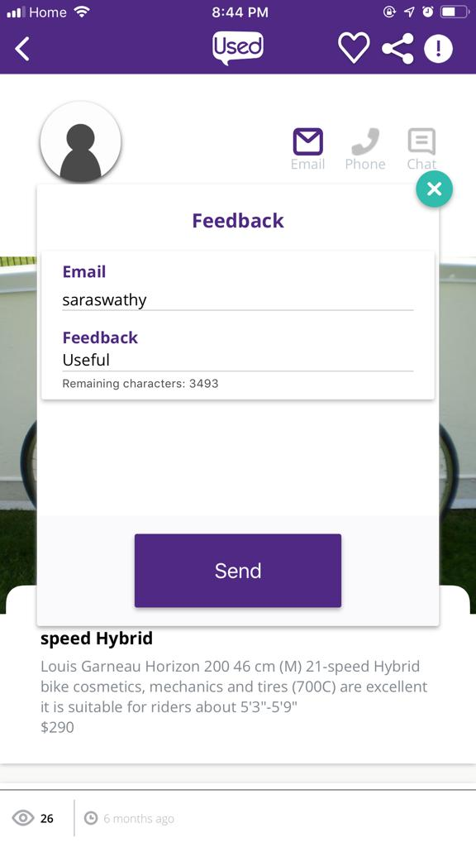

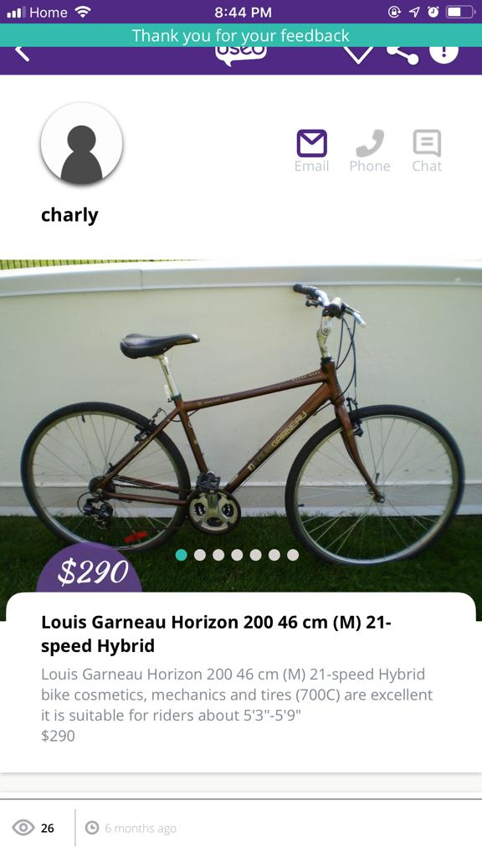

|  |  |
| --- | --- |
| [USED-3] [Placeholder testing - Application responds to the user click after two or three attempts](https://saraswathy.atlassian.net/browse/USED-3) Created: 09/Apr/19  Updated: 09/Apr/19 | |
| **Status:** | To Do |
| **Project:** | [Used](https://saraswathy.atlassian.net/secure/BrowseProject.jspa?id=10000) |
| **Component/s:** | None |
| **Affects Version/s:** | None |
| **Fix Version/s:** | None |

|  |  |  |  |
| --- | --- | --- | --- |
| **Type:** | Bug | **Priority:** | Low |
| **Reporter:** | [Saraswathy Manickam Rameswara Babu](https://saraswathy.atlassian.net/secure/ViewProfile.jspa?accountId=5cab7523a8d493261b3bf5d9) | **Assignee:** | Unassigned |
| **Resolution:** | Unresolved | **Votes:** | 0 |
| **Labels:** | None | | |
| **Remaining Estimate:** | Not Specified | | |
| **Time Spent:** | Not Specified | | |
| **Original Estimate:** | Not Specified | | |

|  |  |
| --- | --- |
| **Sprint:** |  |

|  |  |
| --- | --- |
| **Description** |  |

|  |
| --- |
| Summary : User has to tap the email Id or password placeholder more than once for the keyboard to get displayed.  Software Version of the device : iOS 12.2  Steps to reproduce :  1. User clicks the sign-up button 2. User clicks on the placeholder where the user can give the email and password. 3. User has to tap the screen more than once for the keyboard to display. 4. User enters the email and password in the keyboard appearing on the mobile screen.  Expected Results: User should able to input the value on the first click Actual Result : Application responds to the user click after two or three attempts Priority: Low |

Generated at Tue Apr 09 03:58:18 UTC 2019 by Saraswathy Manickam Rameswara Babu using Jira 1001.0.0-SNAPSHOT#100099-sha1:8dcf83ba1213d40ca3dc27c16353c61be85bc8d7.